## RDS Team Dynamics *Bi-Weekly Update*

**Assignment Goals / Deliverables:** Continuing the theme set with our first Team Dynamics assignment, we want you to get together with your team for a social activity either in-person or virtually (whichever you feel comfortable with). You can share a meal together, play a game, or something along those lines. This gathering should help you unwind a little, and allow you to reflect upon how your team has been performing over the last two weeks. As deliverables, we ask that you complete the following two tasks and upload them to the Canvas assignment:

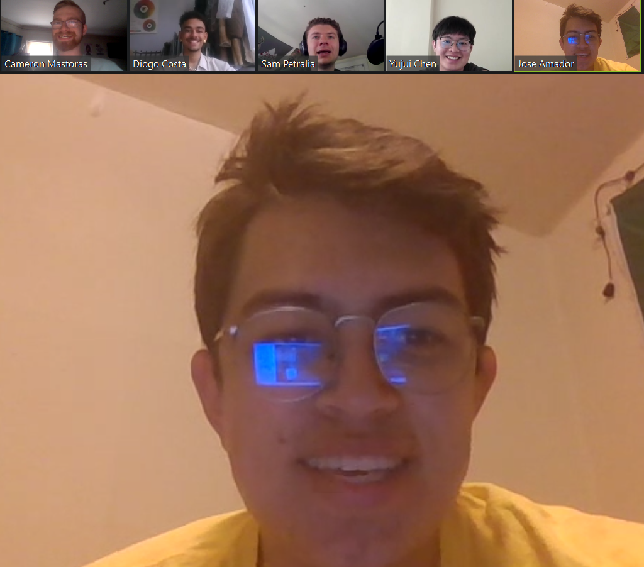

***Please be open and honest with yourselves and your group. There will be no penalties for the answers you provide in these bi-weekly updates, rather they should help you find areas for potential growth and help you recognize individual and team development.***

1. Have there been any conflicts or issues that have arisen within your team over the last two weeks? If so, what were they, and how were they resolved?

| There are no active conflicts, although we recognized that we have had some struggles keeping whole team communication going and ensuring that we are all on the same page. To address this we have all come together and created a list of actionable items, assigned to each team member, to ensure everyone knows what they have to do to finish Beta. |
| --- |

1. Are there any conflicts or issues within your team that are still outstanding that you would like to discuss during your next weekly meeting?

| We believe we have been able to address all current issues internally and just look forward to finishing on a high note. |
| --- |

1. Are there any areas where you feel your team is excelling?

| We are excelling at enjoying ourselves as a team, during our last weeks together, while building an awesome robot. |
| --- |

1. Are there any areas where you feel your team needs improvement?

| As mentioned, the main thing we need to improve is ensuring active communication between each other and ensuring we all get our assigned tasks done on their respective deadlines, to avoid delaying the process to the finish line. The end of the year has definitely had us worned out, but we are committed to completing the project to the standard of the work we have been putting out for the past 6 months. |
| --- |